

Brgy. Ibabang Dupay, Lucena City, 4301 Teach Society

 09926409125  teachsocietyorganization@gmail.com

TECHNICAL EDUCATORS ACHIEVING CONSOLIDATION AND HUMANITY
ACCOMPLISHMENT REPORT

T-Shirt and Lanyard Release for BTVTEd students

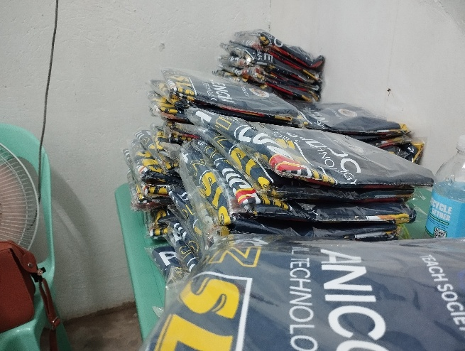
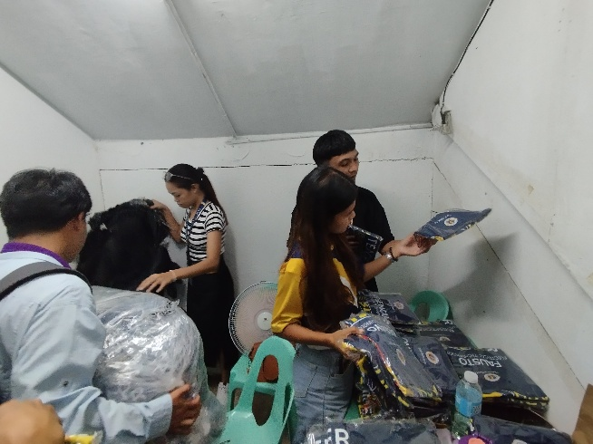

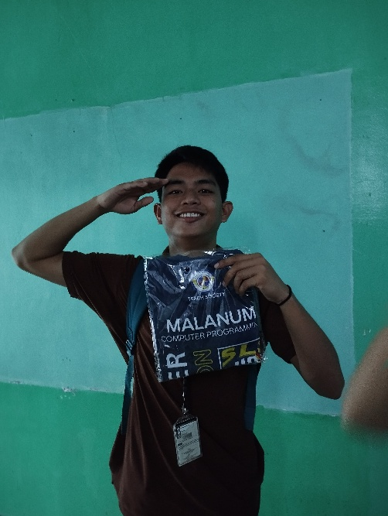

The TEACH SOCIETY successfully conducted the T-Shirt and Lanyard Release for BTVTEd students. The activity aimed to provide official organizational apparel and accessories that symbolize unity, identity, and pride among members of the program. With the efforts of the TEACH SOCIETY officers, the distribution was carried out smoothly and systematically, ensuring that students from various year levels were accommodated. A total of 184 T-Shirts and 69 Lanyards were distributed, and students expressed their appreciation and enthusiasm in receiving the official merchandise. This initiative not only strengthened camaraderie among the BTVTEd students but also enhanced the visibility and recognition of the TEACH SOCIETY within the campus. Overall, the project was a success, reflecting the commitment of the organization in promoting solidarity and engagement among its members.

